Financial Advisor App for Students
Camille Embree, Hoang-Nghi Nguyen

Schedule and Validation

REVISION – Draft
20 February 2025

Execution Plan:
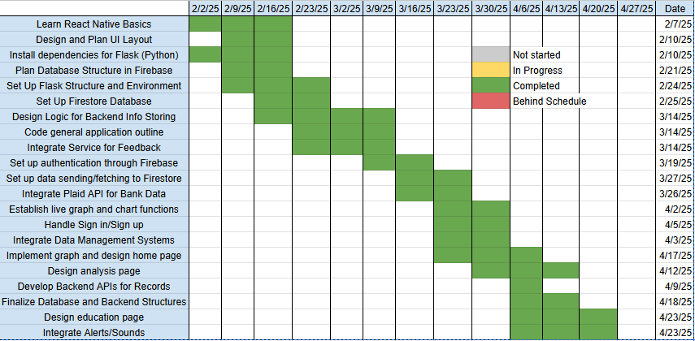

Validation Plan:
